**REGISTRATION FORM**

Name _____________________________

FL Bar No (if applicable)______________

Address ____________________________

City/State/Zip________________________

Billing Address (if different from above)

___________________________________

Phone Number ___________________________________

Email Address _______________________

**REGISTRATION FEES (check one):**

**Pre-Registration** On-Site

☐ NSU SELS members **$20** $30

☐ Non-NSU SELS members **$30** $40

☐ Attorneys for CLE **$45** $55

**METHOD OF PAYMENT (check one):**

☐ Check payable to

**Nova Southeastern University**

☐ Credit Card (Advance registration only)

Name on Card ___________________________________

Card No. ___________________________________

Exp. Date __________________

CVV2 (3-digit code on back of Card) _____

Signature ___________________________

Date _______________________________

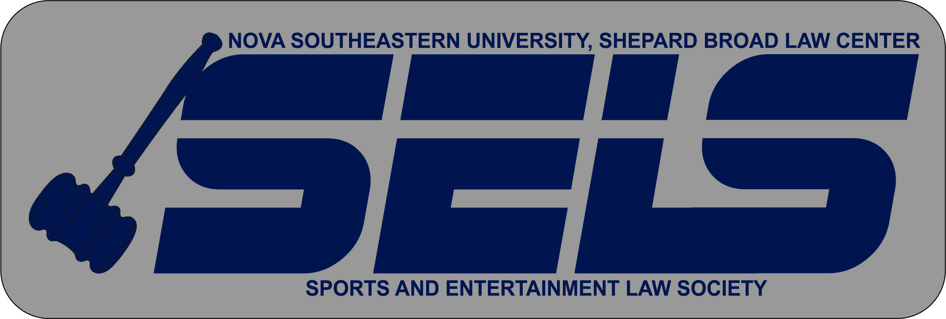

**2012-2013 Executive Board**

**Jared Guberman**, President jg1449@nova.edu

**Mike Cubbage**, VP of Sports mc2149@nova.edu

**Dan Kerness**, VP of Entertainment dk451@nova.edu

**Johnathan Nunn**, Treasurer jn513@nova.edu

**Ryan Lipella**, Social Chair rl880@nova.edu

**Silvia Anderjuk**, Historian

sa838@nova.edu

**Visit our Website at:**

**http://nsulaw.nova.edu/students/orgs/sels/**

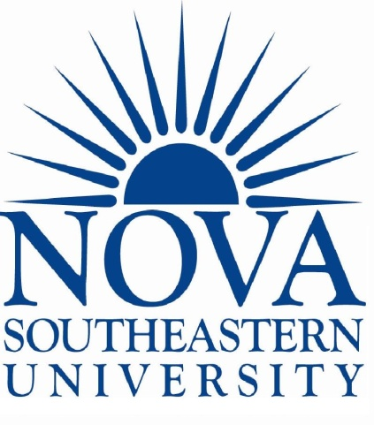

**Sports & Entertainment**

**Law Society**

*Presents*

The Sixth Annual

Nova Southeastern University

**Sports & Entertainment**

**Law Symposium:**

Saturday,

February 23, 2013

**Nova Southeastern University**

**Shepard Broad Law Center**

**3305 College Avenue**

**Davie, FL 33314**

-Limited Seating-

-Register Today-

9:00-9:45 **Check-In and Breakfast**

9:45-10:00 **Opening Remarks**

10:00-11:00 (Panel #1)

**Music Royalties: Revenue from Digital Distribution**

Panelists:

**John Bradley, Esq.**

**David Bercuson, Esq.**

**Marc Stollman, Esq.**

11:00-12:00(Panel #2)

**Collective Bargaining Agreements: NFL, NBA, NHL, MLB**

Panelists:  
 **Alan Fertel, Esq. - NFL**

**Robert Karpeles, Esq. – NHL**

**Pete D’Alessandro - NBA**

12:00-1:15 **Luncheon** Keynote Speaker – **Pete D’Alessandro,** Vice President of Basketball Operations w/ the Denver Nuggets (Nova Law Grad)

1:15-2:15(Panel #3)

**Gaming Law: Casinos, the Internet, Ethics and beyond**

Panelists:

**Alan Koslow, Esq.**

**Lawrence Walters, Esq.**

**Steven Geller, Esq.**

**Robert M. Jarvis**

2:30-3:15 (Panel #4)

**Bankruptcy and Estate Planning Issues: Involving Protection and Sale or Acquisition of Copyrights and Trademarks**

Panelists:

**Charlotte Towne, Esq.**

**Richard Wolfe, Esq.**

**Hillel Presser, Esq.**

**More panelists to be named**

**CLE CREDIT**

CLE Credits

General 6.0

Ethics 0.5

Certification Credits

Business Litigation 2.0

Elder Law 1.0

Intellectual Property 2.5

Labor and Empl. Law 4.5

Wills, Trusts, & Estates 1.0

_______________________________________

How to Register?

1. To register by e-mail, please scan and send this completed application with payment information to SELS President, Jared Guberman, at [jg1449@nova.edu](mailto:jg1449@nova.edu)
2. To register by fax, please send this completed application with payment information to (954) 306-6027
3. To register by mail, please send this application and payment to:

Attn: Naomi Scheiner

Nova Southeastern University, Shepard Broad Law Center

3305 College Avenue

Fort Lauderdale, FL 33314

Questions? Contact SELS President, **Jared Guberman,** by phone **(561) 251-8570** or email **jg1449@nova.edu**

We would like to thank the following sponsors:

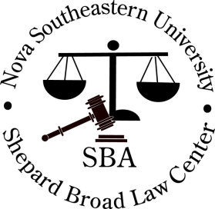



[LexisNexis®](http://www.lexisnexis.com/lawschool/default.aspx)

**___________________________________